# General

## Introduction and Intended Use (Informative)

The purpose of this Recommended Practice is to define communication between Power Stations and Command Stations in the context of decoder based feedback transmission.

The S-9.3.2 Basic Decoder Transmission standard defines a method for communication originating from a DCC Decoder. The standard only specifies manufacturer-independent methods for data transfer from the Decoder to a track-side detector and possibly a second detector in the Power Station. The S-9.3.2 standard does not specify how this returned information should reach the Command Station or any user interface. This requires manufacturers to define and implement proprietary methods of data transfer, causing engineering costs for manufacturers, additional cabling requirements for customers, and making the detectors and Power Stations incompatible between different manufacturers. Important use-cases from the goals of the decoder transmission are thus difficult to implement for manufacturers, thereby impeding innovation and limiting the availability and versatility of products available in the market that support the Decoder Transmission protocols.

## References

This Recommended Practice is interpreted in the context of the following NMRA Standards, Technical Notes, Technical Information, and other documents.

### Normative

* S-9.1.2 Power Station Interface, which defines [one way] communication from Command Stations to Power Stations
* S-9.3.2 DCC Basic Decoder Transmission, which defines communication from a DCC decoder to a track circuit based detector

### Informative

* TN-9.1.2 Power Station Interface, which provides commentary on the Power Station Interface
* TN-9.1.2.1 Power Station Interface Feedback, which provides commentary on the Power Station Interface Feedback
* RCN-217 DCC Feedback Protocol (RailCom), with which S-9.3.2 is intended to be in harmony

## Terminology

| **Term** | **Definition** |
| --- | --- |
| Power Station Feedback | A means of transmitting information from a Power Station to a Command Station. |
| DCC Positive Polarity | The wire or rail which has a positive voltage for the first half of the DCC bipolar bit. |
| Command Station | The DCC system component whose purpose is to generate and send a stream of DCC bit data to the Power Station Interface. |
| Power Station | A device intended to amplify the low current DCC electrical signals transmitted by a Command Station for the purpose of providing high current DCC signals with sufficient power to operate model trains and any accessory decoders that are connected to the track. Also known as booster or power booster. |
| Power Station Interface | The communications medium ("wires") which connect a Command Station's signal generator to one or more Power Stations. |
| Power Station Interface Repeater | A device that amplifies the Power Station Interface signal to allow additional capacity for more Power Stations to be connected. |
| TIAEIA-485 | ANSI differential signal standard commonly known as RS-485. |
| Cutout | This is a period of time during which the amplified track output is disconnected from the two track wires so that the two track wires can be shorted together. |

## Requirements

This Recommended Practice in its entirety is optional. Products that implement the techniques defined in this document must remain capable of operating exactly as defined in S-9.1.2, either through configuration or by automatic means.

# Electrical Characteristics

## Current Loop Interface

### Description (Informative)

The Current Loop Interface uses the methods defined in S-9.3.2 Basic Decoder Transmission to transmit feedback data on the Power Station Interface wiring. The Power Station implements the role of the Transmitter, and the Command Station implements the role of Cutout Device and Detector. The expected implementation is that Power Stations would act as a repeater, transmitting the data bits received from the track by the Global Detector, synchronously and without buffering, to the Power Station Interface cabling via a Transmitter circuit.

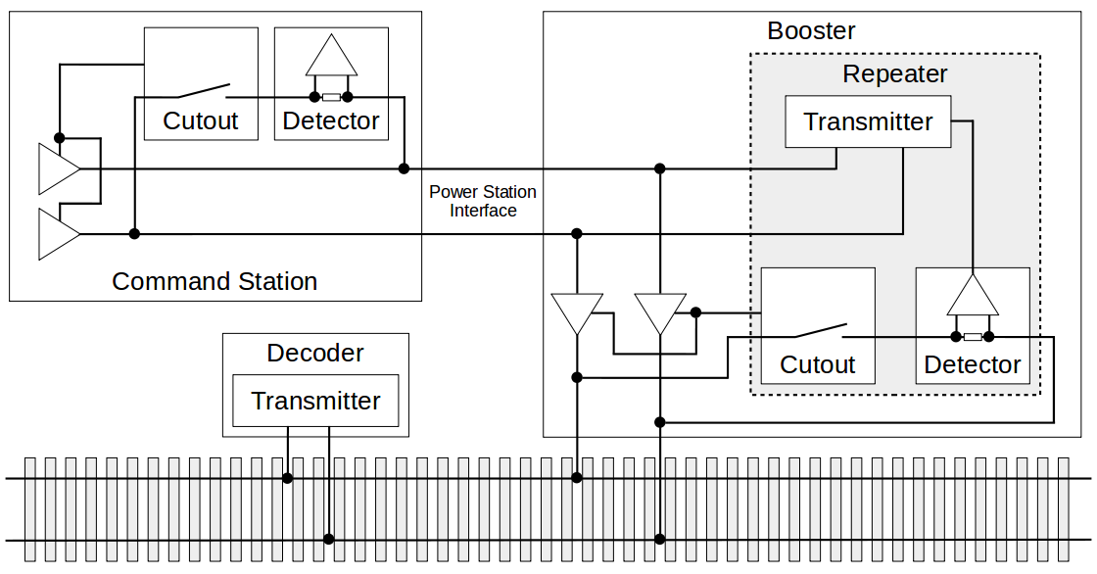  
Figure 1: Power Station Interface Feedback Simplified System Block Diagram

Because the transmission medium of the Power Station Interface has different characteristics than a typical track circuit, care must be taken that the electrical specifications differ from the values set in S-9.3.2.

### Requirements (Normative)

In this method of feedback, the Command Station shall create a cutout on the Power Station Interface by disconnecting the Power Station Interface power source and shorting the two wires together through a detector. Exactly one detector is allowed and shall be integrated into the Command Station. Each Power Station may become a transmitter during the cutout.

### Physical Layer

#### Cabling

Cabling used for the Power Station Interface shall have a characteristic impedance of 100Ω ± 15% at 1-100 MHz. The conductor shall be, or have less than or equal DC resistance to, 24 AWG solid copper.

#### Command Station

During the cutout, starting at or before the Start Channel 1 time, the Command Station must have a termination impedance between the two Power Station Interface signals of 100Ω ± 15% in order to match that of the cabling. The detection circuit shall interpret a current of greater than 2.5 mA during the middle 50% of the bit time as a ‘0’, and a current smaller than 1.5 mA during the middle 50% of the bit time as a ‘1’. The start of the bit time is measured relative to the leading edge of a data byte’s start bit at the detector.

The feedback timing shall exactly match that of S-9.3.2 requirements except for the following changes:

1. The End Channel 1 and End Channel 2 times are extended at the detector in the Command Station by 4 microseconds to 181 microseconds and 458 microseconds respectively.
2. The Cutout End minimum time is extended by 4 microseconds to 458 microseconds.

#### Power Station

The Power Station is implied to have integrated support for a cutout and detector as defined in S‑9.3.2. A Power Station shall forward received decoder transmission onto the Power Station interface. The Power Station may introduce additional latency of up to 2 microseconds and additional asymmetrical bit edge jitter of up to ± 0.2 microseconds, as measured relative to the leading edge of a data byte’s start bit at the Power Station Interface’s feedback transmitter.

To transmit a ‘0’, during the cutout, a Power Station shall supply a current of 5 ± 1 mA through the Power Station Interface. The direction of the current shall such that it is sourced into the DCC positive polarity Power Station Interface signal and sunk at the opposite polarity Power Station Interface signal.

A Power Station shall not forward received decoder transmissions that are always broadcast in nature.

During the cutout, a Power Station shall not have leakage current greater than ± 50 µA with a voltage differential up to 600 mV present on the Power Station Interface.

A power station shall not violate the cutout timing requirements defined in S-9.3.2 at its track output, regardless as to whether or not the incoming Power Station Interface signal has a delayed Cutout End maximum time of up to 4 microseconds. A Power Station shall maintain a valid DCC bit level at its track output during any non-overlapping cutout period in the case where the Power Station Interface cutout time is longer than the Power Station cutout time at the track output.

## Open Collector Acknowledgement Interface

# Topology

# Labeling

# Trademarks and Acknowledgements

* RailCom® is a registered trademark of the company Lenz® Elektronik GmbH, Giessen, Germany